**Accessing PowerForm Data in PI-EDW**

Nov 2018

Author:

*THOMAS W. MAHONEY, Lt Col, USAF, MC*

*Deputy Chief Medical Information Officer*

*AFMSA/SG3OH*

*7700 Arlington Blvd, 4NW441G*

*Falls Church, VA  22042*

*☎: 703 681 7973*

*Email:  thomas.w.mahoney6.mil@mail.mil*

**PowerForm data is available in at least two universes in PI-EDW**:

ODS Documentation

ODS Clinical Outcomes

The clinical outcomes universe contains additional clinical and administrative data and may be the most useful universe to build queries in.

Within this universe is a folder “Documentation”

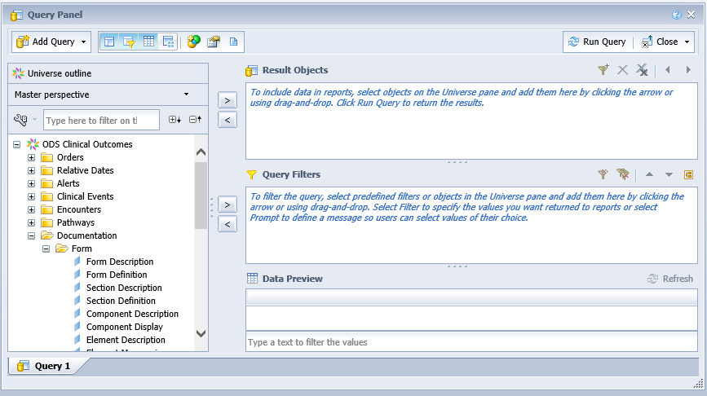

In the “Form” folder are several objects that can be selected. These are the primary components for building a query

* Form Definition – the name of a PowerForm
* Section Definition – the name of a section of a PowerForm (may vary from the display name of the section in a form)
* Element Mnemonic – the name of a DTA on a particular PowerForm Section
* Result Value (in the Response folder) – the recorded response for an Element Mnemonic object

There are other objects in the Response folder that can help filter to desired results such as Documentation Date & Time, Performing Personnel etc.

Additionally if you want to be able to look at a particular documents in PowerChart you can include the object “Formatted Financial Nbr” (located in the Encounters\Encounter Identifiers folder) to drill in to particular encounters.

All of these elements can be combined to produce a query. Below is a very simply query that would prompt for the input of desired Element Mnemonic and then return the value of that Mnemonic along with the associated encounter for every instance within the designated timeframe it has been recorded in the system. (note “Admit Date” refers to the date of an encounter whether inpatient or outpatient)

